TP R MUSU

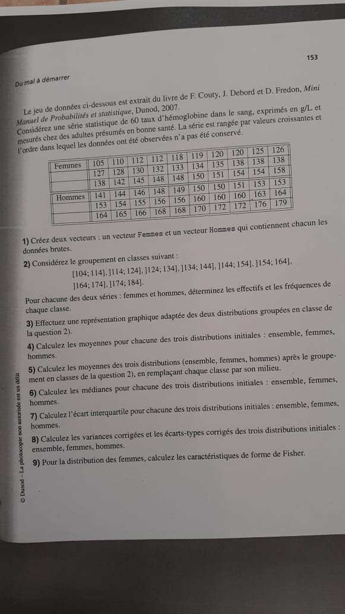

1) > femmes<-c(105,110,112,112,118,119,120,120,125,126,127,128,130,132,133,134,135,138,138,138,138,142,145,148,148,150,151,154,158)

> femmes

[1] 105 110 112 112 118 119 120 120 125 126 127 128 130 132 133 134 135 138 138 138 138 142 145 148 148 150 151 154 158

> Hommes<-c(141,144,146,148,149,150,150,151,153,153,154,155,156,156,160,160,160,163,164,164,165,166,168,168,170,172,172,176,179)

> Hommes

[1] 141 144 146 148 149 150 150 151 153 153 154 155 156 156 160 160 160 163 164 164 165 166 168 168 170 172 172 176 179

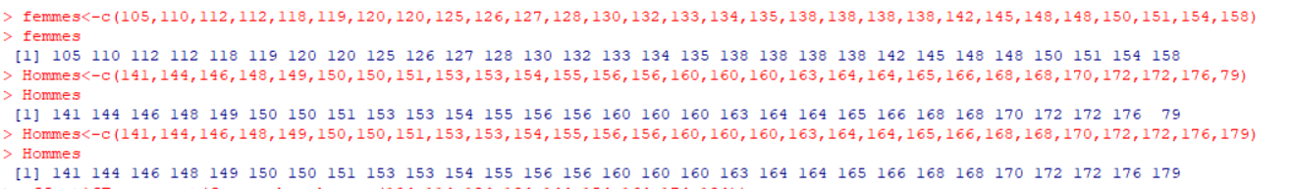

2) effectifFemmes=cut(femmes, c(104,114,124,134,144,154,164,174,184))

> effectifFemmes

[1] (104,114] (104,114] (104,114] (104,114] (114,124] (114,124] (114,124] (114,124] (124,134] (124,134] (124,134] (124,134] (124,134] (124,134] (124,134] (124,134] (134,144] (134,144]

[19] (134,144] (134,144] (134,144] (134,144] (144,154] (144,154] (144,154] (144,154] (144,154] (144,154] (154,164]

Levels: (104,114] (114,124] (124,134] (134,144] (144,154] (154,164] (164,174] (174,184]

> table(effectifFemmes)

effectifFemmes

(104,114] (114,124] (124,134] (134,144] (144,154] (154,164] (164,174] (174,184]

4 4 8 6 6 1 0 0 

> effectifHommes=cut(Hommes, c(104,114,124,134,144,154,164,174,184))

> effectifHommes

[1] (134,144] (134,144] (144,154] (144,154] (144,154] (144,154] (144,154] (144,154] (144,154] (144,154] (144,154] (154,164] (154,164] (154,164] (154,164] (154,164] (154,164] (154,164]

[19] (154,164] (154,164] (164,174] (164,174] (164,174] (164,174] (164,174] (164,174] (164,174] (174,184] (174,184]

Levels: (104,114] (114,124] (124,134] (134,144] (144,154] (154,164] (164,174] (174,184]

> table(effectifHommes)

effectifHommes

(104,114] (114,124] (124,134] (134,144] (144,154] (154,164] (164,174] (174,184]

0 0 0 2 9 9 7 2



> FrequenceFemmes<-table(effectifFemmes) / 30

> FrequenceFemmes

effectifFemmes

(104,114] (114,124] (124,134] (134,144] (144,154] (154,164] (164,174] (174,184]

0.13333333 0.13333333 0.26666667 0.20000000 0.20000000 0.03333333 0.00000000 0.00000000

> FrequenceHommes<-table(effectifHommes) / 30

> FrequenceHommes

effectifHommes

(104,114] (114,124] (124,134] (134,144] (144,154] (154,164] (164,174] (174,184]

0.00000000 0.00000000 0.00000000 0.06666667 0.30000000 0.30000000 0.23333333 0.06666667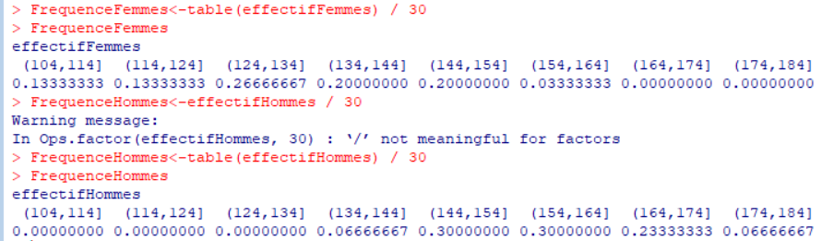

3) plot(effectifFemmes, xlab="effectif", ylab="tauxd(hémoglobine dans le sang(g/L)", main="Femmes")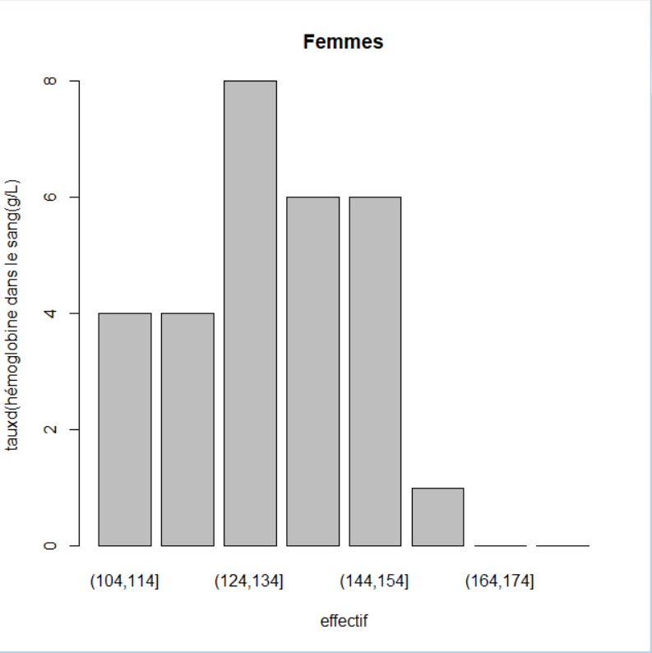

> plot(effectifHommes, xlab="effectif", ylab="tauxd(hémoglobine dans le sang(g/L)", main="Hommes")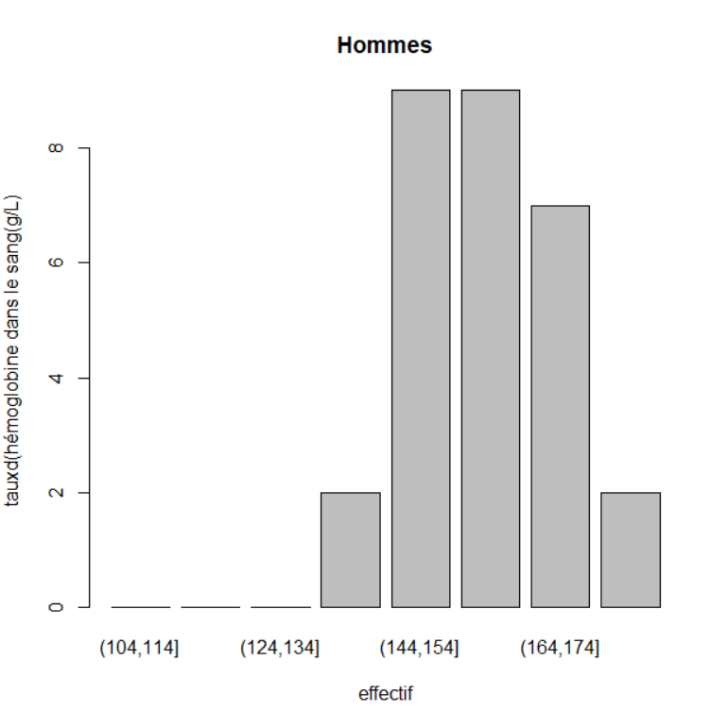

4) > mean(femmes)

[1] 132.2069

> mean(Hommes)

[1] 159.069

> mean(c(Hommes,femmes))

[1] 145.6379

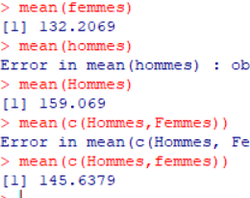

5)

6) > median(Hommes)

[1] 160

> median(femmes)

[1] 133

> median(c(Hommes,femmes))

[1] 148.5

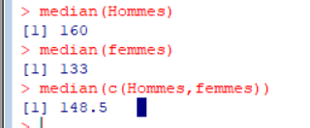

7) > quantile(Hommes,probs=c(0.25,0.5,0.75))

25% 50% 75%

151 160 166

> quantile(femmes,probs=c(0.25,0.5,0.75))

25% 50% 75%

120 133 142

> quantile(Hommes,femmes,probs=c(0.25,0.5,0.75))

25% 50% 75%

151 160 166

Warning message:

In if (na.rm) x <- x[!is.na(x)] else if (anyNA(x)) stop("missing values and NaN's not allowed if 'na.rm' is FALSE") :

la condition a une longueur > 1 et seul le premier élément est utilisé

> quantile(c(Hommes,femmes),probs=c(0.25,0.5,0.75))

25% 50% 75%

133.25 148.50 159.50

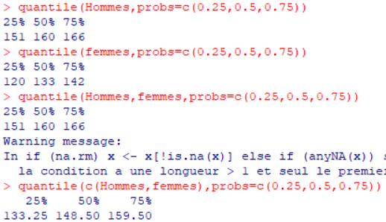

8)

9)